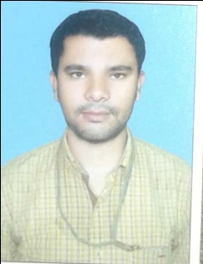
Md.Irfan
Present Address
F 2/219, Saheen Bagh
Okhla New Delhi 110025
Email ID : mdirfan51094@gmail.com
Mobile NO:+91 9430261321, +91 9430004537

CAREER OBJECTIVE:

- Seeking a better placement in a professional managed organization where i can enhance my working skill a grow further in terms of successfully accomplishment of duties and increase emoluments for betterment of career at the same time. I will try my best to fulfill the expectation of employers and perceive my work best for company.

PROFESSIONAL QULIFICATION

- MBA (Finance) Session 2015-2017 from L.N. Mithila University Darbhanga Bihar , with 1st Div. 68%
ACADEMIC QULIFICATION:
- 10th From Bihar Board Patna(2009) With 2nd Division Percentage 58%.
- Intermediate(Commerce) From Bihar Board Patna (2011) With 1st Division Percentage 63.88%
- B.Com From L.N.M.U Darbhanga Bihar(2014) With 2nd Division Percentage 54.33%
COMPUTER SKILL
Diploma in Computer Accounting
Tally ERP 9
WORKING EXPREINCE:
1 Year Worked in Rajeev and Chartered Accountant company Patna , Bihar
Currently Working from Aust 17 to till Date in PI Associate Okhla New Delhi
PERSONAL INFORMATION
- Fathers name : Md. Izharul haque
- Date of birth : 05/10/1994
- Gender : Male
- Religion : Islam
- Marital status : Single
- Nationality : Indian
- Blood group : O+
- language known : Hindi, English & Urdu
DECLARATION

I hereby declared that the information above is true and correct to the best of my knowledge.

Date:-

Place:- Md. Irfan

