Rajesh Kumar

Mob No- 9431445001
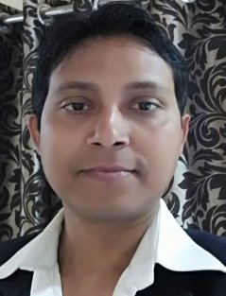
Email- kumarrajesh1610@gmail.com

Objective
· Start my career as a successful 9 years as faculty and learn all the skills
involved in development of this industry by working in a team.
· Gradually enhance my abilities reach to a renowned level.
· Explore my leadership qualities and lead myself to be a successful citizen.

Education and Qualifications
· B.Sc fromT.M.U ,Bhagaplur(Bihar)
B.Ed. from Banka
M.Sc From T.M.U Bhagalpur( Bihar)
· Schooling fromST Josephs High School, Asansol(WB).

Work Experience
· Two year working with Focus IIT Academy Delhi
· Three year Working with Takshila Academy Punjabi bag Delhi
· Four year Tula’s International School Dehradun
Currently working with Mount Zion School Bhagalpur

Personal Profile
· Highly innovative, confident, goal-oriented and able to relate to and create
trust in all; love challenges in work.
· A strong persuasive power and leadership qualities with an excellent
communication skills, succeeding in interacting and convincing others.
· A high teamspirit; able to create a lively working environment; good sense
of humor.
· Optimistic, energetic, a strong determination and hard working.
· Persistent and always a very secure approach for achieving the set target

Hobbies
· Reading, Chess, Music, Surfing.

