RESUME
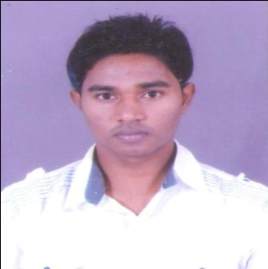
NIRANJAN MEHER
C/o. Late Balaram Meher
At-Nadipara, Po-Bargarh
Dist-Bargarh - 768028
Odisha
Mobile –91-7873192443,6370644235
E-MAIL : meherniranjan92@gmail.com
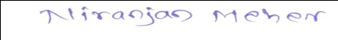

CAREER OBJECTIVES :
To be a part of reputed organization, where myself motivated attitude can trigger symbiotic growth and contribute to the all round development of the parties involved.
EDUCATIONAL QUALIFICATIONS:

Professional Qualification:
- Matriculation – Under Board of Secondary Education, Odisha, in the year passing 2007.
- Higher Secondary (+2 Commerce) – Under Council of Higher Secondary Education, Odisha in the year passing 2009.
- Graduate – Bachelor of Commerce under sambalpur university, odisha in the year of passing 2013
- Diploma of Computer Administration under I-Tech Institute
- Tally ERP 9 Under Odisha Sakhyatra Mission Sambalpur

EXPERIENCE:

    - I have worked as a Data Entry Operator in Preet Tractor, Bargarh for 6 months.

    - I have worked as an Assistant Accountant in Niki Resorts Pvt Ltd Sambalpur for 2.5 years.

    - I have worked as an Accountant in Jindal Food Product for 2 years

    - Now I am working as an Accountant in Balgopal Food Product since October 2020.

    - Fully expertise Tally ERP 9

KEY STRENGTH:
- Taking each and every work as a challenge
- Easily adjustable in every situation
- Willingness to learn
- Convincing power.

HOBBIES & SPECIAL INTEREST:
- Reading Books.
- Making friends
- Playing Cricket

PERSONAL DETAILS :
Name : Niranjan Meher
Father’s Name : Late Balaram Meher
Date of Birth : 02nd July, 1992
Gender : Male
Marital Status : Married
Nationality : Indian
Religion : Hindu
Languages Known : English, Hindi & Odia
Hobbies : Reading Books and Magazines
Permanent Address: At-Nadipara, Po/PS-Bargarh
Dist-Bargarh (Odisha)

DECLARATION:
I hereby declare that all the statements made above are true to the best of my knowledge and belief.

DATE: 27.10.23
PLACE: BARGARH NIRANJAN MEHER

