Banshi Vishwakarma

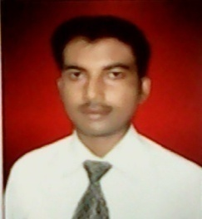

Communication Address :-

S/O :- Sri Rama Kant Vishwakarma
Sector-1, Jhopri Market,
Shop No.-11, P.O.- Dhurwa,
Ranchi- 834004
(JHARKHAND)
Mobile No. – 09835505175
e-mail :- banshivishwakarma25@gmail.com

Academic Qualification :-

Graduation in Science (Chemistry Hons.)

Personal Profile :-

Father’s Name :- Sri Rama Kant Vishwakarma

Date of Birth :- 25.09.1979

Sex :- Male

Nationality :- Indian

Religion :- Hindu

Marital Status :- Married

Language Known :- English & Hindi

Hobbies :- Listening music

Experience :-

** Worked as Medical Representative in SHINCE PHARMACEUTICALS Pvt. Ltd., Chennai from 09/11/2007 to
16/07/2011 (3yrs & 8 months) at Hazaribag Hqr.

** Worked as Business Development Executive in HLL LIFECARE LTD., Women’s Healthcare Division, Chennai
from 20/07/2011 to 14/11/2015 (4yrs & 4 months) at Ranchi Hqr.

** Worked as Product Delegate in GENO PHARMACEUTICALS Pvt. Ltd., Goa from 15/11/2015 to 31/07/2018
(2yrs & 8 months) at Ranchi Hqr.

** Worked as Senior Business Executive based at Ranchi Hqr in PLASORON BIOTECH Pvt. Ltd., Delhi from
01/08/2018 to 10/06/2022.

** Working as Area Sales Manager based at Ranchi Hqr. in Medillios Private Ltd., Delhi from 13/06/2022…

Date :-

Place :- Signature of Candidate

