RESUME
G.M.KEZIAH  10-75/10-193 CHENKARAVILLAI  NEYYOOR POST  KANYAKUMARI DISTRICT 629802  EMAIL ID:keziahgm93@gmail.com  CONTACT:9176853509 | 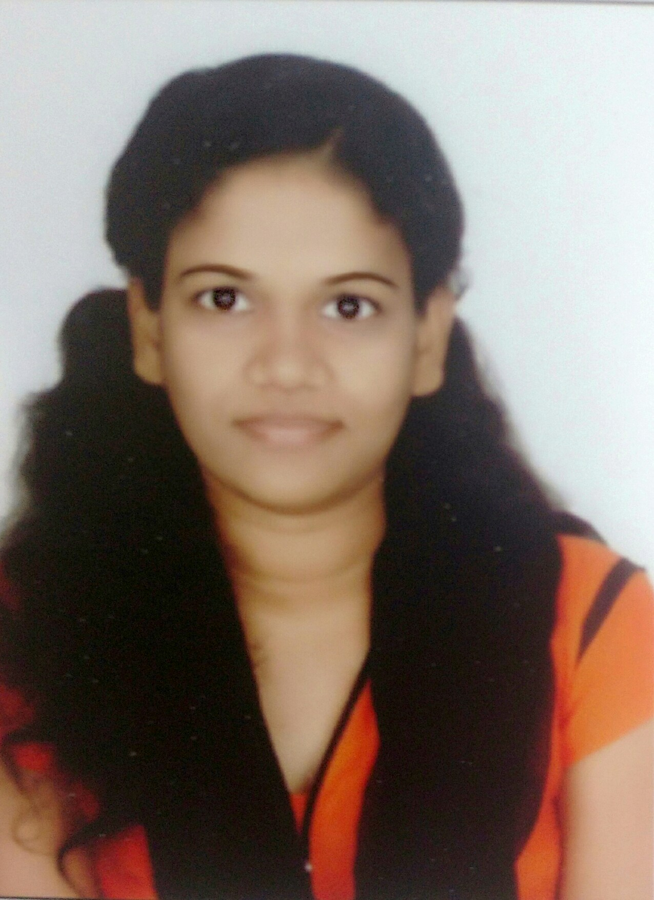

CAREER OBJECTIVE:
To acquire a position most suited to my skills and capabilities and also endeavor to make the best use of my skill sets and potential to benefit the organization.

PERSONAL STRENGTH:
- Optimistic person
- A good team player
- Hard worker and quick learner
- Dedicated towards work
- Good communication skill

EDUCATIONAL QUALIFICATION:

QUALIFICATION | SCHOOL/COLLEGE | PERCENTAGE | YEAR OF PASSING
B.E | Arunachala college of engineering for women | 8.20 CGPA | 2015
Higher Secondary | Victory matriculation higher secondary school | 82.67 | 2011
High School | Victory matriculation higher secondary school | 94 | 2009

EXPERIENCE
Currently working as officer in Wipro having 7 months of experience in Human Resource Operations
ADDITIONAL QUALIFICATION:
- Office automation
AREAS OF INTEREST:
- Digital image processing
- Electronics
TECHNICAL SKILLS:
- Basics of C, C++, MATLAB
PAPER PRESENTATION:
- Presented a Paper on National Conference “TIEC 2013”’
- Presented a Paper on National Level Technical Symposium “ADCOMTEX-2K14”
- Presented a Seminar on the topic “RMS meter”

TRAINING/WORKSHOP:
- IET sponsored Workshop on “Recent trends in Control design and Image Processing using MATAB” on 5th October, 2013
- Three days Workshop on “MATLAB Programming, Application to Signal and Image Processing” from 12th June to 14th June, 2014
- Training on “Fundamentals of Telecom” at BSNL, Nagercoil

PROJECT:
Block Based Robust Blind Image Watermarking Technique using DWT, SVD and
Torus Automorphism.

ACHIEVEMENTS:
- Passed with Distinction in “Holy faith Talent Search Examination”
- Secured First Class in “State level Universal Talent Search Examination”
- Secured Grade A in “PCM scholarship Examination”
- Won a Merit Award for coming as a class toper in Anna University 4th semester Exam

PERSONAL DETAILS:
- NAME : Keziah G M
- DATE OF BIRTH : 30.12.1993
- GENDER : Female
- NATIONALITY : Indian
- MARITAL STATUS : Single
- LANGUAGES KNOWN : English, Tamil

HOBBIES:
- Gardening and Photography

Place: Yours faithfully,
Date: (Keziah)

